PROJECT SYNOPSIS ON

*EFFICIENT COURIER TRACKING SYSTEM*

Submitted for partial fulfillment of Award of

BACHELOR/MASTERS OF COMPUTER APPLICATION

2020-21(Even Sem)

By

Your Name Roll Number write

Under the Guidance Of

MR. Teacher Name

## COLLEGE NAME WRITE HERE FULL, LUCKNOW



**Affiliated to**

**UNIVERSITY NAME, LUCKNOW**



# INTRODUCTION

Courier service providers usually have a very large network across countries. A courier goes through several places including distribution centre and delivered using transportation services like, aero plane, ship, road transport etc. All customers would like to track their consignment through online or via email or SMS, whatever options that might be convenient to them.

Customer can track his/her order, till where the courier has been reached just by logging in and entering courier number to track the location of the package. Here we propose a dedicated courier tracking system where customer may check the status and location of his/her courier.

Here every distribution channel terminal has a system operated by authorized people at that particular point of distribution. Each distribution has login access. On logging, the person needs to make an entry of a package number that should be reaching to him/her. This data is directly uploaded to the main system that now keeps track of latest location and status of the package through an active internet connection. The data stored on server can now be used for live package status tracking by customers. Customers may login in to the server in order to enter their unique courier tracking number. On entering the number system, they get the last recorded status of that particular package and shows this data to the user. The user may now track his package as and when needed. The courier tracking system can be further improved by adding a barcode to every package so that every point just needs to scan the barcode instead of doing a manual entry of package number.

# Problem Definition

In traditional system of courier or parcel management, it is typical to track the exact record because it’s very lengthy and hectic. Traditional system takes more time and manual reporting is also not perfect, that generates the requirement of new system that is Efficient Courier Tracking System.

## Problem Objective

The actual problem is to maintain different database for a courier company whose main purpose is to provide parcel services for their customers for different places, and maintain details of all the transactions, employees and address details. In the manual system it is difficult to maintain data and generating different reports according to requesting transaction. In the present courier system always they have to take source as well as destination information which contains address details, parcel contents details etc. By keeping all the above activities we are developing a system named as “EFFICIENT COURIER TRACKING SYSTEM”. In this automation system we are maintaining company as well as customer details related to courier service and courier management that contains the user as well as admin details.

# Purpose of the Proposed Project

The Existing System is only to track the courier status. In the case of sending courier is done manually. User has to visit and do the manual process of filling the applications. A system that existing currently may lead to confuse the handling of bulk amount of data due to inefficient manual process. Manual Process increases the inefficiency of the courier management. That eventually results in:

* Manual Operations
* Time taken to process is high
* Missing of records

Making it application based, user can easily track his/her courier status accordingly. Thus it will be beneficial for customer as well as for admin to manage and update all the details. Thus the proposed system will be:

* Easy Use Of Courier Service
* Reducing Time Taken to Send courier
* Improved Courier System
* Easy to Access and user friendly

# PROPOSED METHODOLOGY

**About Software Development Life Cycle:**

### Software Development Life Cycle (SDLC) is a process used by the software industry to design, develop and test high quality softwares. The SDLC aims to produce a high- quality software that meets or exceeds customer expectations, reaches completion within times and cost estimates.

* SDLC is the acronym of Software Development Life Cycle.

### It is also called as Software Development Process.

* SDLC is a framework defining tasks performed at each step in the software development process.

### ISO/IEC 12207 is an international standard for software life-cycle processes. It aims to be the standard that defines all the tasks required for developing and maintaining software.

SDLC is a process followed for a software project, within a software organization. It consists of a detailed plan describing how to develop, maintain, replace and alter or enhance specific software. The life cycle defines a methodology for improving the quality of software and the overall development process.

## Prototype Model:

The Prototyping Model is one of the most popularly used Software Development Life Cycle Models (SDLC models).This model is used when the customers do not know the exact project requirements beforehand. In this model, a prototype of the end product is first developed, tested and refined as per customer feedback repeatedly till a final acceptable prototype is achieved which forms the basis for developing the final product.

In this process model, the system is partially implemented before or during the analysis phase thereby giving the customers an opportunity to see the product early in the life cycle. The process starts by interviewing the customers and developing the incomplete high-level paper model. This document is used to build the initial prototype supporting only the basic functionality as desired by the customer. Once the customer figures out the problems, the prototype is further refined to eliminate them. The process continues until the user approves the prototype and finds the working model to be satisfactory.

## Advantages:

* The customers get to see the partial product early in the life cycle. This ensures a greater level of customer satisfaction and comfort.
* New requirements can be easily accommodated as there is scope for refinement.
* Missing functionalities can be easily figured out.
* Errors can be detected much earlier thereby saving a lot of effort and cost, besides enhancing the quality of the software.
* The developed prototype can be reused by the developer for more complicated projects in the future.
* Flexibility in design.

## Disadvantages:

* Costly with respect to time as well as money.
* There may be too much variation in requirements each time the prototype is evaluated by the customer.
* Poor Documentation due to continuously changing customer requirements.
* It is very difficult for developers to accommodate all the changes demanded by the customer.
* There is uncertainty in determining the number of iterations that would be required before the prototype is finally accepted by the customer.
* After seeing an early prototype, the customers sometimes demand the actual product to be delivered soon.
* Developers in a hurry to build prototypes may end up with sub-optimal solutions.
* The customer might lose interest in the product if he/she is not satisfied with the initial prototype.

**Use:**

The Prototyping Model should be used when the requirements of the product are not clearly understood or are unstable. It can also be used if requirements are changing quickly. This model can be successfully used for developing user interfaces, high technology software- intensive systems, and systems with complex algorithms and interfaces. It is also a very good choice to demonstrate the technical feasibility of the product.

The various phases of Prototype model are as follows:

**Recognition of Need**: One must know what the problem is before it can be solved.

**Feasibility Study**: A Feasibility study is a set of a system proposal according to it’s workability impact on the organization.

**Analysis**: It is the detailed study of the various operations performed by a system.

**Design**: The term describes the final system and the process by which it is developed.

**Coding**: The programs co-ordinate the data movements and control the entire process in a system.

**Implementation**: It is the stage of the project in which theory is turned into practice.

**Testing**: Before actually implementing the new system into operations, a test run of the system is done to remove all the bugs, if any.

**Maintenance**: It is necessary to eliminate errors in the system during it’s working life.

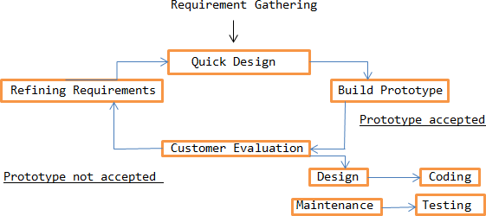

# Technology Involved for the making of project:

Below are the information about some of the main technologies used for the development of the project:

## About Python:

Python is an interpreted, object-oriented, high-level programming language with dynamic semantics. Its high-level built in data structures, combined with dynamic typing and dynamic binding, make it very attractive for Rapid Application Development, as well as for use as a scripting or glue language to connect existing components together. Python's simple, easy to learn syntax emphasizes readability and therefore reduces the cost of program maintenance. Python supports modules and packages, which encourages program modularity and code reuse. The Python interpreter and the extensive standard library are available in source or binary form without charge for all major platforms, and can be freely distributed.

## About Django Framework:

Django is a high-level Python web framework that enables rapid development of secure and maintainable websites. Built by experienced developers, Django takes care of much of the hassle of web development, so you can focus on writing your app without needing to reinvent the wheel. It is free and open source, has a thriving and active community, great documentation, and many options for free and paid-for support.

## About MySql:

***MySQL is a database management system.***

A database is a structured collection of data. It may be anything from a simple shopping list to a picture gallery or the vast amounts of information in a corporate network. To add, access, and process data stored in a computer database, you need a database management system such as MySQL Server. Since computers are very good at handling large amounts of data, database management systems play a central role in computing, as standalone utilities, or as parts of other applications.

# Software and Hardware Requirements

## Software Requirement Specifications:

A set of programs associated with the operation of a computer is called software. Software

is the part of the computer system which enables the user to interact with several physical hardware.

The minimum software requirements for developing the project are as follows: Designing Frontend: HTML,CSS, Java Script, Django Framework

Backend (Database): MySql

## Hardware Requirement Specifications:

The collection of internal electronic circuits and circuits and external physical devices used in building a computer is called Hardware.

The minimum hardware requirement specification for developing this project is as follows: RAM: 512 MB

Space Requirement: 1 GB

# Modules of the Project

These are some of the modules that can be implemented onto the project:

The system comprises of 3 major modules with their sub-modules as follows:

1. **Admin:**
   * **View User:** Admin can view all information about the user.
   * **View package status:** Admin can view the package status.
2. **User:**
   * **Login:** User can login his account using id and password.
   * **View package status**: User can view the package status.

Some other modules that can be implemented are as follows:

* + Request For Courier Service
  + Allocate Service
  + Updation of Courier Status
  + Tracking the Courier

**MODULE DESCRIPTION:**

#### Request For Courier Service

* + In this module, User is making a request to admin that they need to send the courier with the details.
  + Users also add the details of courier like sender name, sender address, material weight, material type and their own details.
  + Then admin can view the request from user and then view their details.

#### Allocate Service

* + Admin is viewing the details and they can allocate the delivery persons to the particular address to receive
  + Once they received the courier from the user then they can allocate the delivery person to deliver the item to particular address
  + User payment details are also updated to admin by delivery person who is receiving the courier from user who made request.

#### Updation of Courier Status

* + In this module, Service Person that is Delivery Person is about to update the status of their own
  + Service Person alone responsible for updation of courier status to admin as well as user
  + Once they receive the courier from user they also made a updation about payment

#### Tracking the Courier

* + This is user side module. User can Track their courier by id which is allocated to the transportation that also intimated them previously
  + There is another way of tracking also available to view the updation about their courier service
  + By Viewing in list as per they made request..

**Software Design**

The design phase of software development deals with transforming the customer requirements as described in the SRS documents into a form implementable using a programming language.

There are two kinds of design documents developed in this phase: High-Level Design (HLD)

* + Brief description and name of each module
  + An outline about the functionality of every module
  + Interface relationship and dependencies between modules
  + Database tables identified along with their key elements
  + Complete architecture diagrams along with technology details Low-Level Design(LLD)
  + Functional logic of the modules
  + Database tables, which include type and size
  + Complete detail of the interface
  + Addresses all types of dependency issues
  + Listing of error messages
  + Complete input and outputs for every module

**Data Flow Diagram**

#### 0 level DFD diagram:

**DFD Level 0** is also called a Context Diagram. It's a basic overview of the whole system or process being analyzed or modeled. It's designed to be an at-a-glance view, showing the system as a single high-**level** process, with its relationship to external entities.

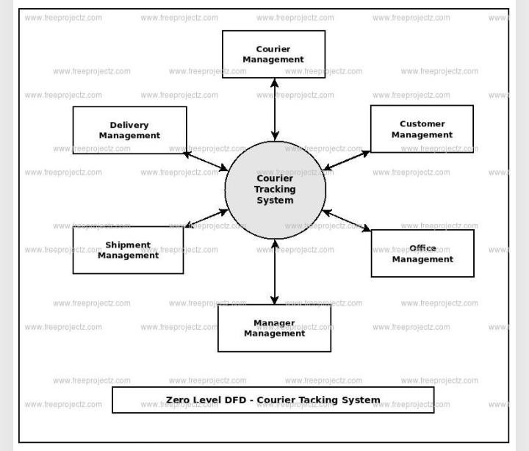

## First level DFD Diagram:

In 1-level DFD, the context diagram is decomposed into multiple bubbles/processes. In this level, we highlight the main functions of the system and breakdown the high-level process of 0-level DFD into subprocesses.

**Admin:**

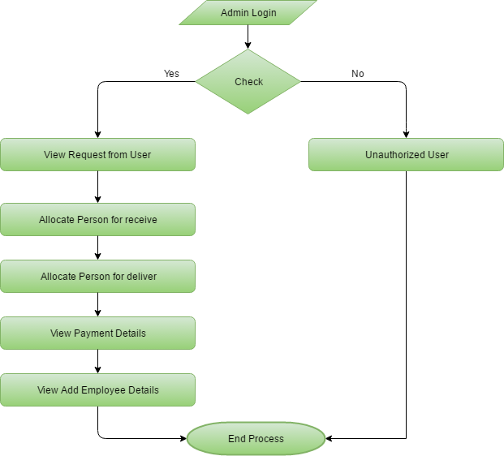

**User:**

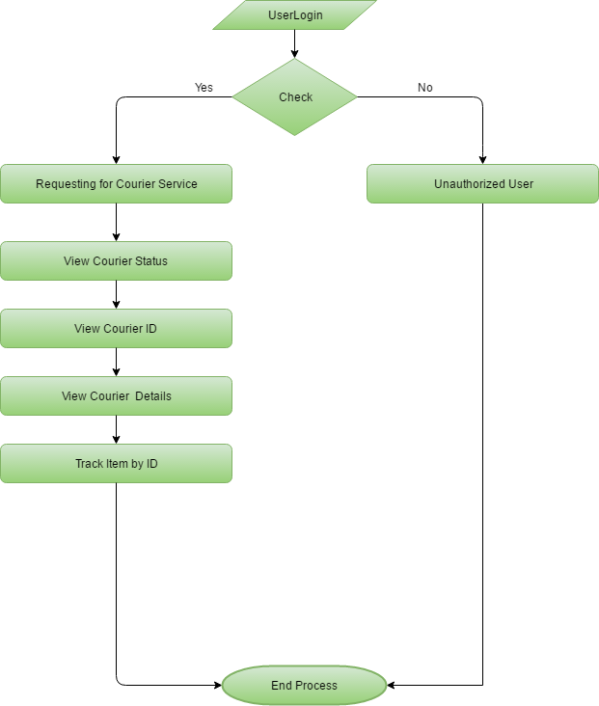

## Use Case Diagram:

A use case diagram at its simplest is a representation of a user's interaction with the system that shows the relationship between the user and the different use cases in which the user is involved.

## Admin:

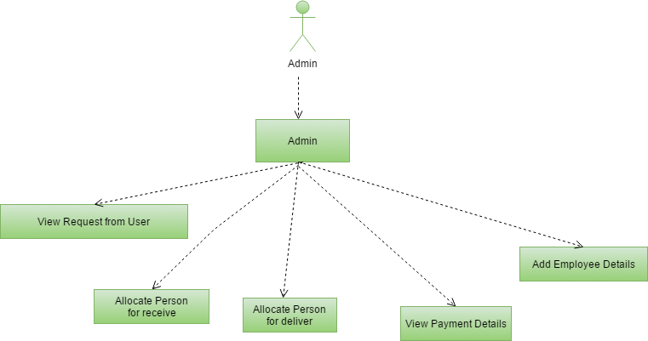

**User:**

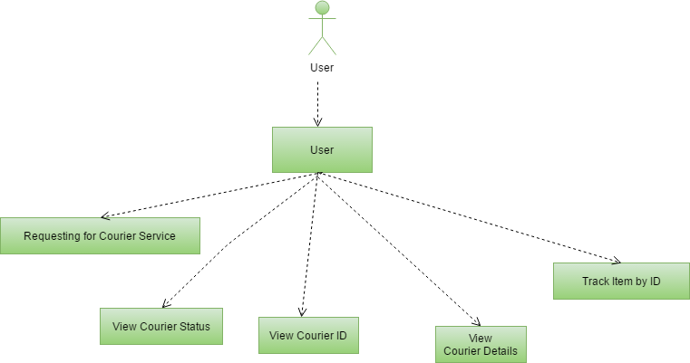

## Entity Relationship Diagram:

**ER Diagram** stands for Entity Relationship Diagram, also known as ERD is a diagram that displays the relationship of entity sets stored in a database. In other words, ER diagrams help to explain the logical structure of databases. ER diagrams are created based on three basic concepts: entities, attributes and relationships.

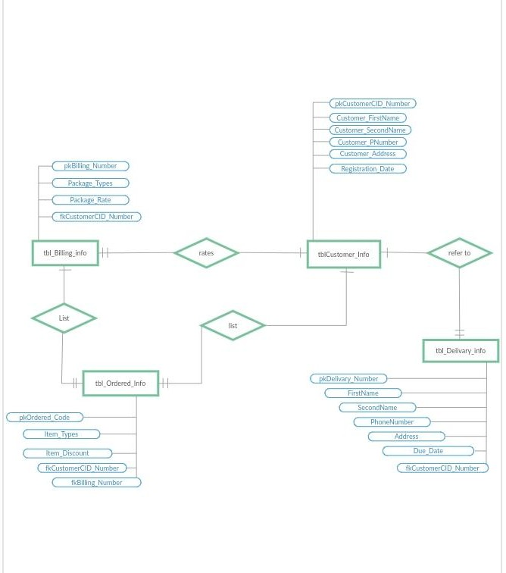

## Advantages

* + Receiver can track his courier or ordered goods.
  + This system can be used in several different domains for tracking goods sent by someone.
  + It even helps the authority to keep an eye on sent goods.

## Limitation

* + Authority at every point has to manually enter the location of the goods.
  + User does not get the exact location of its order.

## Application

* + This can be used by Online Shopping companies to provide online tracking of order to their customers.
  + This System can also be used by Courier companies to let the receiver track his courier.

**References**

1. Rajib Mall, Fundamental of Software Engineering, Third Edition, PHI,2009
2. Elmasri Nevathe, “Fundamentals of Database Systems”.Third Edition, Pearson Publication,2002
3. [https://www.google.com/amp/s/www.geeksforgeeks.org/software-engineering-](https://www.google.com/amp/s/www.geeksforgeeks.org/software-engineering-prototyping-model/amp/) [prototyping-model/amp/](https://www.google.com/amp/s/www.geeksforgeeks.org/software-engineering-prototyping-model/amp/)
4. <https://www.shiprocket.in/blog/courier-parcel-package-tracking-system-working/>
5. <https://www.geeksforgeeks.org/software-engineering-software-design-process/>